**Prompts**

*[Hierarchical Clustering Model Vis] The three figures below (from* [*Interactively exploring high-dimensional data and models in R*](https://dicook.github.io/mulgar_book/8-hierarchical.html) *by Cook and Laa) are different ways of showing the same hierarchical clustering. Explain how the nodes, branches, and leaves in the far left panel appear (or don't) in the middle and right panels. For each panel, explain one aspect of the model or data that it emphasizes and one that it downplays.*

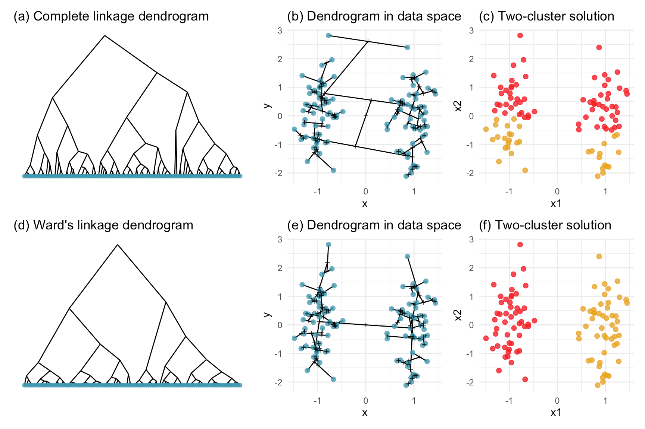

*[Concept Map] Prepare a concept map to summarize the last week of reading material. An effective submission will include a thorough coverage of both abstract concepts and practical examples, summarized concisely into short phrases. It will also include well-justified links between nodes, with text explanations for edges whose interpretation might not be obvious at first.*

**Responses**